String operation

“ABC%”: All strings that start with ABC. Eg: ABCD and ABCDABCD would both satisfy the condition.

“%XYZ”: All strings that ends with xyz. Eg: WXYZ and ZZXYZ.

“%AN%”: All strings that contain the pattern an anywhere. Eg: LOS ANGELES and SAN FRANCISCO.

Find the eno, ename of the employee whose salary is >4000

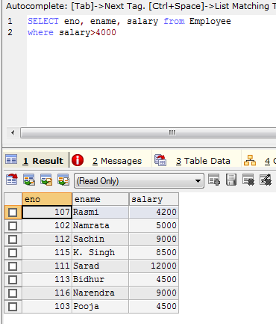

Find the eno, ename salary of the employees whose salary is>5000 and job status is professor

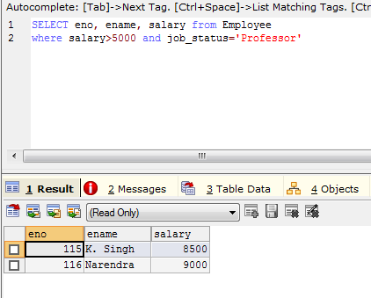

Select address from employee

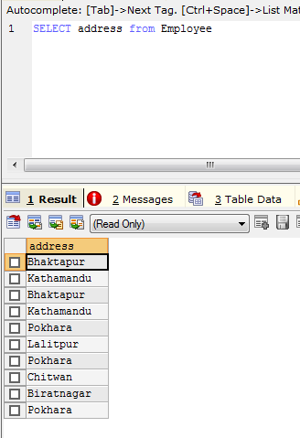

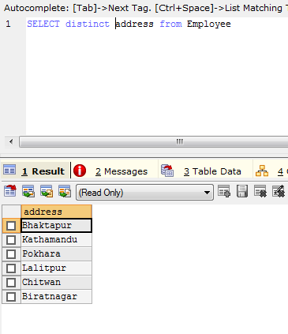

Find the eno, ename, salary of the employee whose department no is 20 or job status is research fellow.

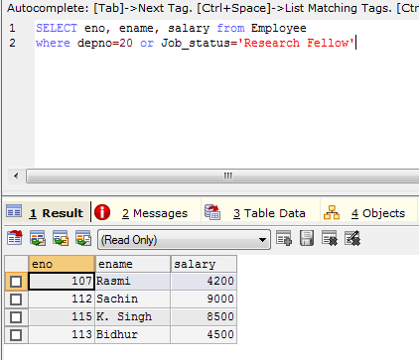

Find the eno, ename, age and salary from the employee where the age is between 24 and 28.

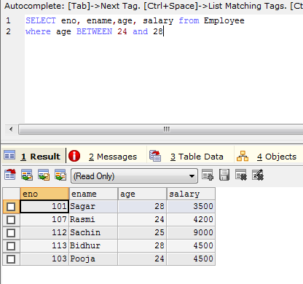

Find eno, ename whose starting letter “sa”.

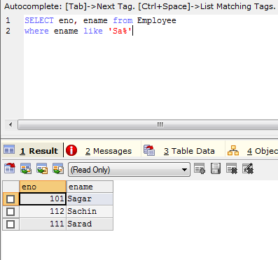

List all employee names with their project name.

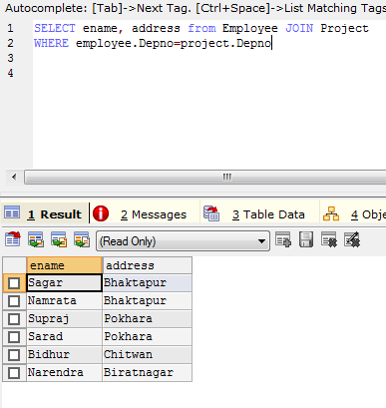

List name of all employee and their salary who are working in project Mars or Venus.

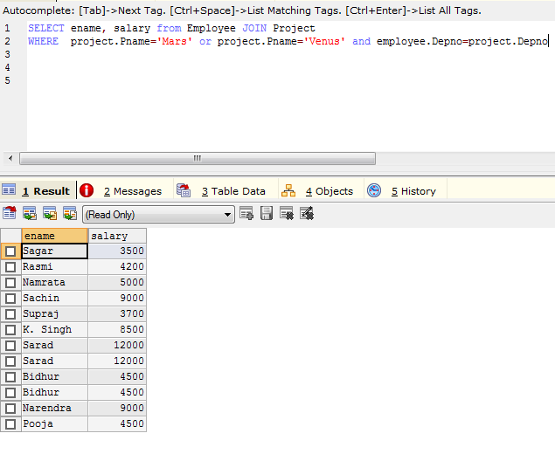

List name of all employee and their salary who are working in project Earth and Venus.

List name and address of all employees who works in department which is located in Pokhara.

